Hasil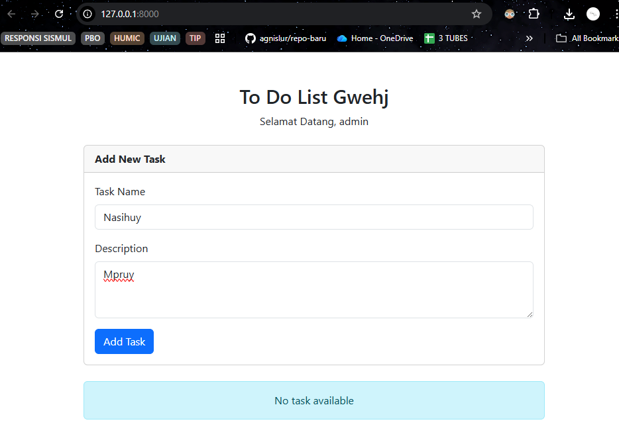
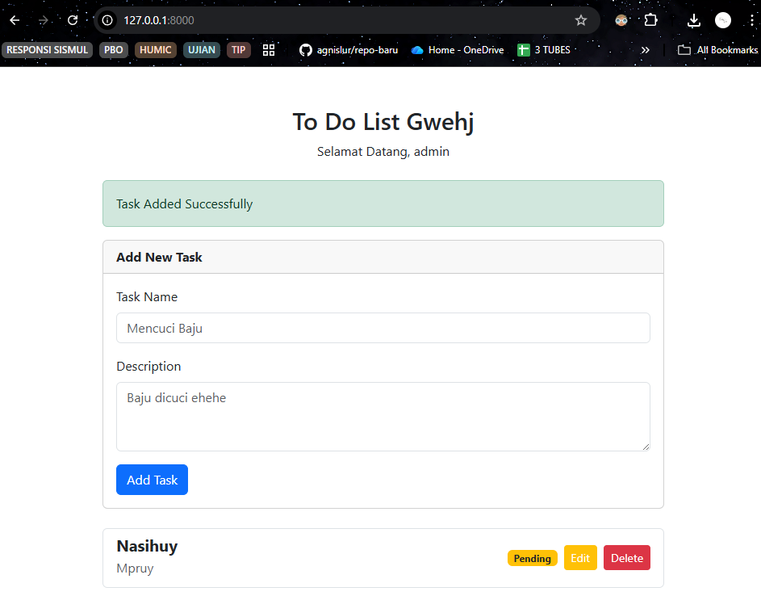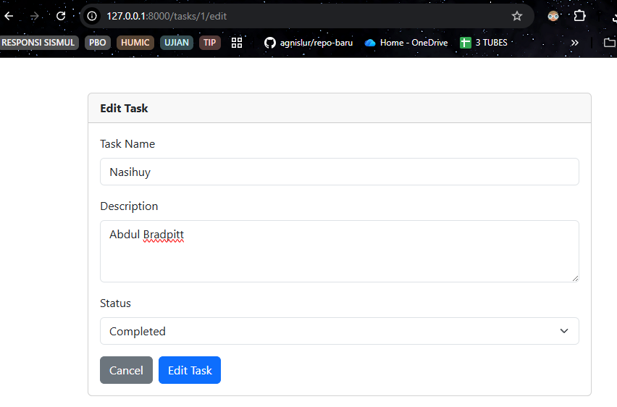
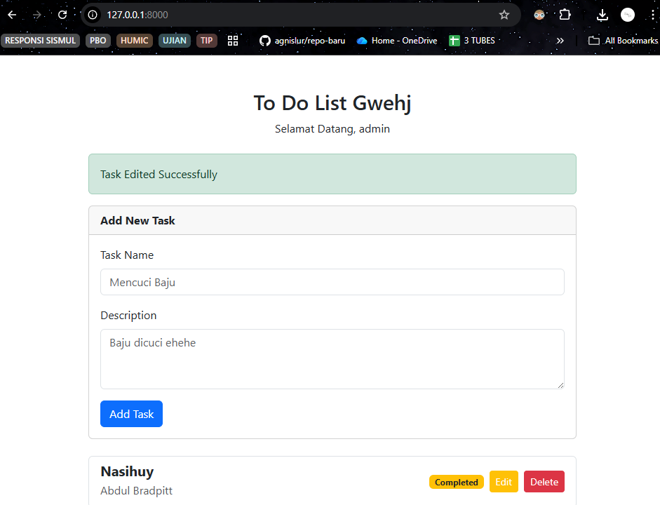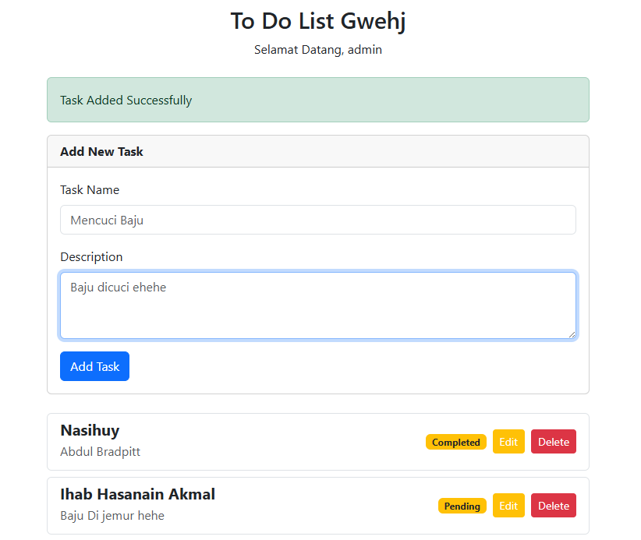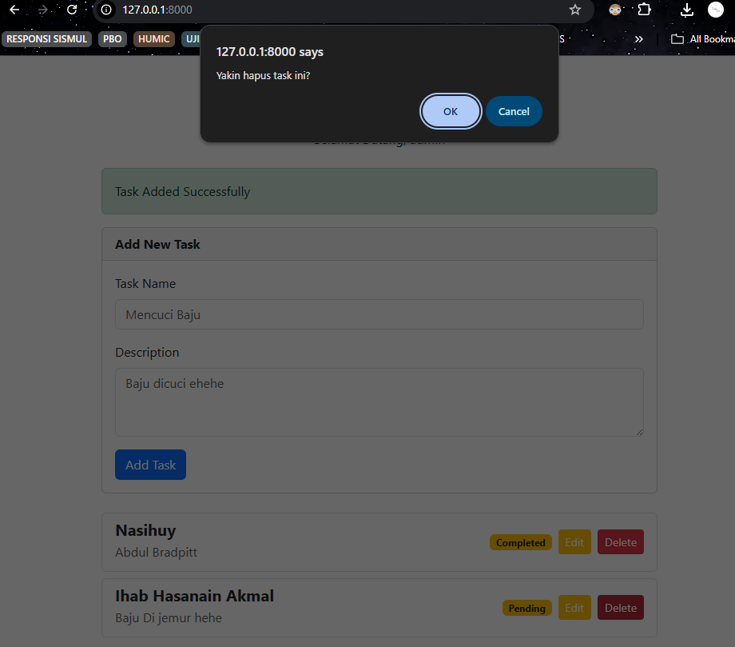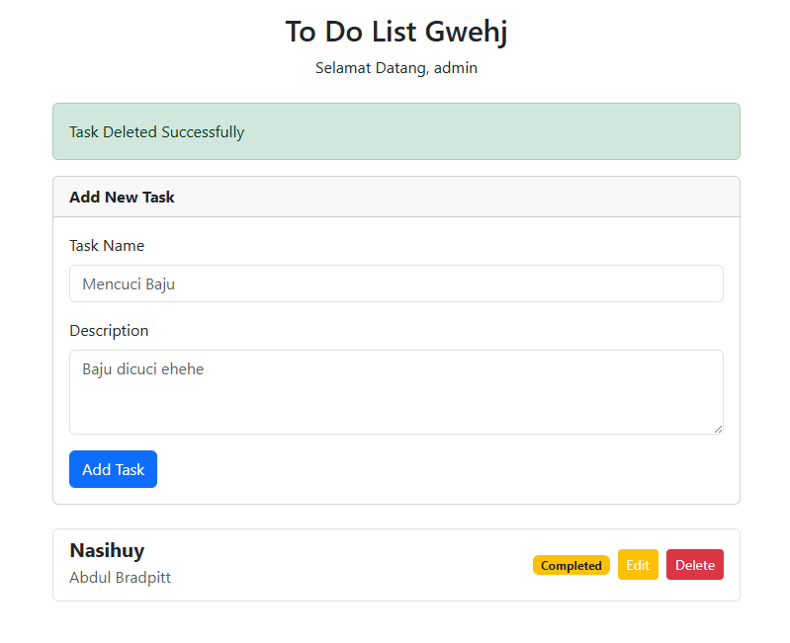
Kode
Database
<?php

use Illuminate\Database\Migrations\Migration;
use Illuminate\Database\Schema\Blueprint;
use Illuminate\Support\Facades\Schema;

return new class extends Migration
{
/**
* Run the migrations.
*/
public function up(): void
{
Schema::create('tasks', function (Blueprint $table) {
$table->id();
$table->string('name');
$table->text('description');

$table->enum('status', ['pending', 'completed'])->default('pending');
$table->timestamps();
});
}

/**
* Reverse the migrations.
*/
public function down(): void
{
Schema::dropIfExists('tasks');
}
};

Models
<?php

namespace App\Models;

use Illuminate\Database\Eloquent\Factories\HasFactory;
use Illuminate\Database\Eloquent\Model;

class Task extends Model
{
use HasFactory;

protected $fillable = [
'name',
'description',
'status'
];
}
Controller
<?php

namespace App\Http\Controllers;

use App\Models\Task;
use Illuminate\Http\Request;

class TaskController extends Controller
{

public function index()
{
$tasks = Task::all();
return view('index', compact('tasks'));
}

public function store(Request $request)
{
$request->validate([
'name' => 'required|string|max:255',
'description' => 'required|string',
]);

Task::create([
'name' => $request->name,
'description' => $request->description,
'status' => 'pending'
]);

return redirect()->route('tasks.index')->with('success', 'Task Added Successfully');
}

public function edit($id)
{
$task = Task::findOrFail($id);
return view('edit', compact('task'));
}

public function update(Request $request, $id)
{
$request->validate([
'name' => 'required|string|max:255',
'description' => 'required|string',
'status' => 'required|in:pending,completed',
]);

$task = Task::findOrFail($id);
$task->update($request->all());

return redirect()->route('tasks.index')->with('success', 'Task Edited Successfully');
}

public function destroy($id)
{
$task = Task::findOrFail($id);
$task->delete();

return redirect()->route('tasks.index')->with('success', 'Task Deleted Successfully');
}
}
Routes
<?php

use Illuminate\Support\Facades\Route;
use App\Http\Controllers\TaskController;

Route::get('/', [TaskController::class, 'index'])->name('tasks.index');

Route::post('/tasks', [TaskController::class, 'store'])->name('tasks.store');

Route::get('/tasks/{id}/edit', [TaskController::class, 'edit'])->name('tasks.edit');

Route::put('/tasks/{id}', [TaskController::class, 'update'])->name('tasks.update');

Route::delete('/tasks/{id}', [TaskController::class, 'destroy'])->name('tasks.destroy');
Index
<!DOCTYPE html>
<html lang="en">
<head>
<meta charset="UTF-8">
<meta name="viewport" content="width=device-width, initial-scale=1.0">
<title>To Do List</title>
<link href="https://cdn.jsdelivr.net/npm/bootstrap@5.3.0/dist/css/bootstrap.min.css" rel="stylesheet">
</head>
<body>
<div class="container mt-5">
<div class="text-center mb-4">
<h2>To Do List Gwehj</h2> <p>Selamat Datang, admin</p>
</div>

@if(session('success'))
<div class="alert alert-success">
{{ session('success') }}
</div>
@endif

<div class="card mb-4">
<div class="card-header fw-bold">Add New Task</div>
<div class="card-body">
<form action="{{ route('tasks.store') }}" method="POST">
@csrf
<div class="mb-3">
<label for="name" class="form-label">Task Name</label>
<input type="text" class="form-control" name="name" placeholder="Mencuci Baju" required>
</div>
<div class="mb-3">
<label for="description" class="form-label">Description</label>
<textarea class="form-control" name="description" rows="3" placeholder="Baju dicuci ehehe" required></textarea>
</div>
<button type="submit" class="btn btn-primary">Add Task</button>
</form>
</div>
</div>

<div class="list-group">
@forelse($tasks as $task)
<div class="list-group-item d-flex justify-content-between align-items-center mb-2 border rounded">
<div>
<h5 class="mb-1 fw-bold">{{ $task->name }}</h5>
<p class="mb-1 text-muted">{{ $task->description }}</p>
</div>
<div class="d-flex align-items-center gap-2">
<span class="badge bg-warning text-dark">{{ ucfirst($task->status) }}</span>

<a href="{{ route('tasks.edit', $task->id) }}" class="btn btn-warning btn-sm text-white">Edit</a>

<form action="{{ route('tasks.destroy', $task->id) }}" method="POST" onsubmit="return confirm('Yakin hapus task ini?');">
@csrf
@method('DELETE')
<button type="submit" class="btn btn-danger btn-sm">Delete</button>
</form>
</div>
</div>
@empty
<div class="alert alert-info text-center">No task available</div>
@endforelse
</div>
</div>

<script src="https://cdn.jsdelivr.net/npm/bootstrap@5.3.0/dist/js/bootstrap.bundle.min.js"></script>
</body>
</html>
Edit
<!DOCTYPE html>
<html lang="en">
<head>
<meta charset="UTF-8">
<meta name="viewport" content="width=device-width, initial-scale=1.0">
<title>Edit Task</title>
<link href="https://cdn.jsdelivr.net/npm/bootstrap@5.3.0/dist/css/bootstrap.min.css" rel="stylesheet">
</head>
<body>
<div class="container mt-5">
<div class="card">
<div class="card-header fw-bold">Edit Task</div> <div class="card-body">
<form action="{{ route('tasks.update', $task->id) }}" method="POST">
@csrf
@method('PUT') <div class="mb-3">
<label for="name" class="form-label">Task Name</label>
<input type="text" class="form-control" name="name" value="{{ $task->name }}" required>
</div>

<div class="mb-3">
<label for="description" class="form-label">Description</label>
<textarea class="form-control" name="description" rows="3" required>{{ $task->description }}</textarea>
</div>

<div class="mb-3">
<label for="status" class="form-label">Status</label>
<select class="form-select" name="status">
<option value="pending" {{ $task->status == 'pending' ? 'selected' : '' }}>Pending</option>
<option value="completed" {{ $task->status == 'completed' ? 'selected' : '' }}>Completed</option>
</select>
</div>

<div class="d-flex gap-2">
<a href="{{ route('tasks.index') }}" class="btn btn-secondary">Cancel</a>
<button type="submit" class="btn btn-primary">Edit Task</button>
</div>
</form>
</div>
</div>
</div>
<script src="https://cdn.jsdelivr.net/npm/bootstrap@5.3.0/dist/js/bootstrap.bundle.min.js"></script>
</body>
</html>

